AI6130: Assignment 1

Benchmark Evaluation with Open-LLM

Submission Details

Due Date: 14 October 2026 (11:59 PM)

Submission: only the report (don’t need to submit code) to NTULearn (do not submit via email):

Link: Assignments → Assignment 1 → Report

Name the submission file: "AI6130-Ass1-YourStudentID"

Objective
In this assignment, you will evaluate LLMs on the Open-LLM-Benchmark using the Hugging Face framework.

Example Codebase
You are provided with an example implementation:
https://colab.research.google.com/drive/1DB9pOMznWuBFHgb8YBRR2Ctbil3l-Qma?usp=sharing
The notebook demonstrates how to:
- Load the Open-Style/Open-LLM-Benchmark dataset from Hugging Face.
- Load an LLM for inference on the benchmark tasks.

Tasks

1. Warm-up
- Read and understand the provided example code.
- Run the notebook to verify your setup.

2. Benchmark Evaluation
- Load three tasks from the Open-LLM-Benchmark:
  - CommonsenseQA
  - OpenbookQA
  - PiQA
- Load four LLMs:
  - TinyLlama_v1.1: TinyLlama/TinyLlama_v1.1
  - Qwen/Qwen2.5-3B-Instruct: Qwen/Qwen2.5-3B-Instruct
  - DeepSeek-R1-Distill-Qwen-1.5B: deepseek-ai/DeepSeek-R1-Distill-Qwen-1.5B
  - Qwen3-4B-Instruct-2507: Qwen/Qwen3-4B-Instruct-2507

- Run each model on all three tasks and record the evaluation results.

3. Prompt Engineering
- Modify the prompt used in the infer_llm function to improve inference, and ensure that it is compatible with the model template (check the Hugging Face model page if available).
- Example modifications:
  - Original Prompt: "Question … Answer"
  - Improved Prompt: "Question … Answer in A/B/C/D"
- You may also implement few-shot prompting (e.g., including multiple examples in the prompt).
- Run each model again on the three tasks with your improved prompts and record the evaluation results.

Deliverables
Report:
- Summarize the results of experiments (preferably in tables)
- Discuss your method of prompt modifications, conduct analysis, comparison, and explanation about the results
- The format is free style. Try to be concise and not more than 5 pages (including the cover page)

---------------------------------------------------------------------

Some useful links:
- Dataset:
Open LLM dataset: Open-Style/Open-LLM-Benchmark
Open LLM Leaderboard: open-llm-leaderboard/open_llm_leaderboard
- Model usage:
For example: microsoft/phi-2
How to load the model using Hugging Face:
- Visit the model page: (https://huggingface.co/ + model name)
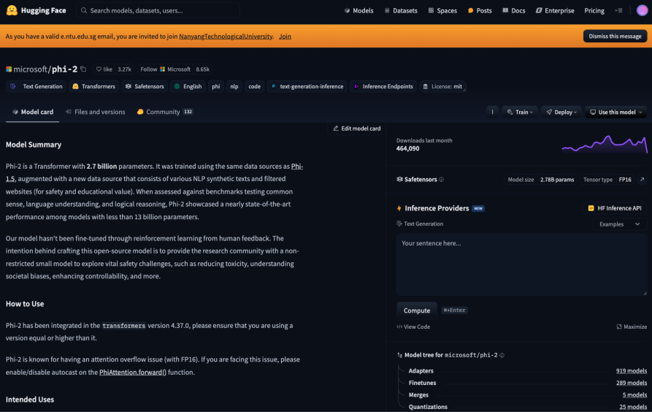
- Click these buttons:
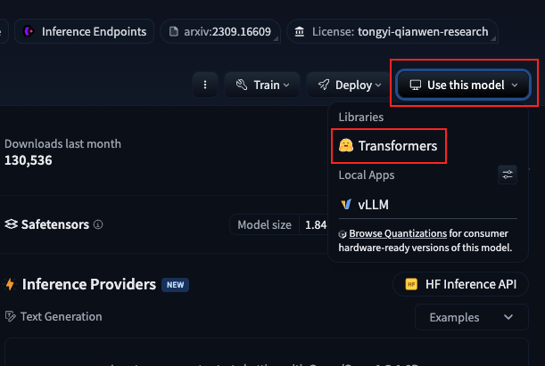
- Copy from the code block using AutoTokenizer and AutoModelForCasualLM into your Google Colab to use the model:
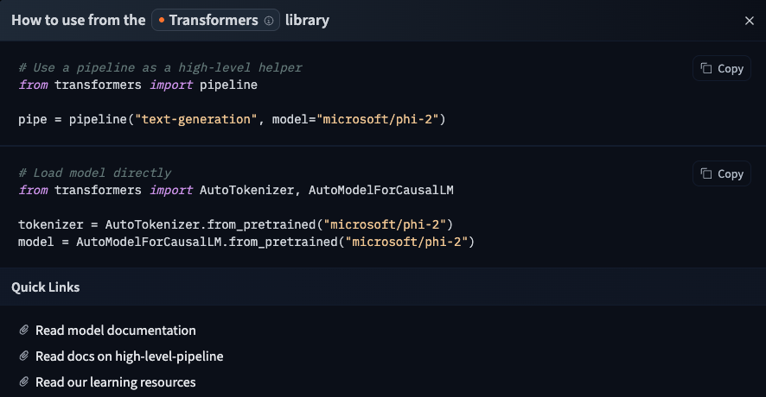
Note: Certain models may provide a predefined chat template, which you should follow if available.
